BACS2073 Software Design and Architecture Tutorial 6 Tutorial 6 – Software Design Patterns
1. What are design patterns?
2. Why design patterns are seen to benefit the software development community? 3. What are creational patterns? What are they used for?
4. Compare and contrasts the following patterns:
(a) Abstract factory
(b) Factory method
(c) Adapter
(d) Decorator
5. Provide a real-life example for each of the following patterns. Discuss each of them. (a) Singleton
(b) Factory method
(c) Strategy
(d) Decorator
(e) Chain of responsibility
6. Compare design pattern with software framework.
7. 2024 May/June (Past Exam)
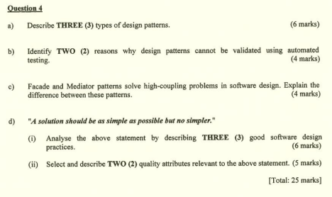Page 1 of 2
BACS2073 Software Design and Architecture Tutorial 6
Additional Questions (Home Work)
a) An ice cream shop is selling various type of ice cream. Customer may buy for the basic type where there is no topping on the ice cream. Customer may request to add different types of topping on the ice-cream. There are three types of topping, chocolate, peanut, raisin. Assume that the basic ice cream costs $1.50 each scoop, and each topping has different cost. Chocolate topping is $0.60, peanut topping is $0.50 and raisin topping is $0.45. A program is created to calculate the total costs for each purchase of the ice-cream.
(i) Suggest ONE (1) design pattern which is suitable for this scenario. Justify your suggestion.
(ii) Draw a UML class diagram to illustrate the design pattern for the program structure.
b) A newly established development company is appointed to develop a vaccination scheduling software. The software is used to process the vaccination request of a person. When the person registers and request for vaccination, the person is required to input his information such as name, identity card number, personal health information such as medication, surgical history, and so on. In addition, there are different types of requests according to the age of the person, country of origin and nature of work. The request not only consists of personal information, it also consists of the information for/from each sub-process of vaccination. The type of request and its information will be sent to a series of processes but not all processes will be used to handle a request type. The process will pass the request to other processes if it finds that the request is not intended for itself. In each process, the information will be processed by a series of functions related to the information provided. The company has employed a software architect as a contract staff for the project. The software architect is in the midst of deciding on whether to apply the chain of responsibility or mediator design patterns.
(i) Based on the scenario, which design pattern is more suitable? Justify your answer.
(ii) Suggest the creational pattern(s) that is suitable in the creation of a request instance. Justify your answer.
Page 2 of 2

